|  |
| --- |
| [Type the company name] |
| FLOOD MONITORING |
| AND EARLY WARNING |

|  |
| --- |
| SUMMITTED BY ,  V.Praharsha  au723921243058  Praharshasingle@gmail.com |

**INNOVATION**

A flood monitoring innovation project aims to develop and implement advanced technologies and strategies to improve flood detection, prediction, and mitigation. Flooding is a natural disaster that can cause significant damage to infrastructure, disrupt communities, and even result in loss of life. By leveraging innovative solutions, we can enhance our ability to monitor and respond to floods effectively. Here are some key components and innovations commonly found in such projects:

**1.Remote Sensing Technologies**: Utilizing satellite imagery, radar, and drones to monitor changes in weather patterns, water levels, and flooding conditions. This data can be used to predict flood events and assess their impacts.

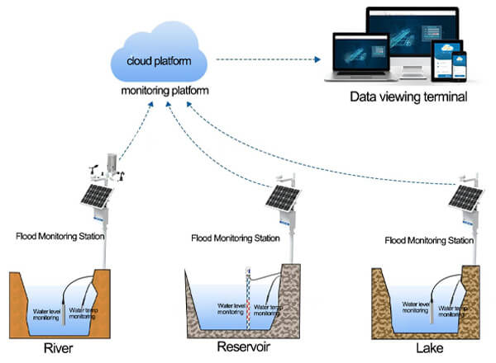

**2.Data Analytics and Machine Learning**: Applying data analysis and machine learning algorithms to process and interpret vast amounts of data from various sources, enabling more accurate flood predictions and early warnings.

**3.Real-time Monitoring Systems**: Developing sensor networks and monitoring systems that continuously collect data on rainfall, river levels, soil moisture, and other relevant parameters to provide real-time information on flood conditions.

**4.Flood Forecasting Models**: Developing sophisticated flood forecasting models that integrate data from multiple sources to predict the timing, extent, and severity of potential floods.

**5.Community Engagement and Mobile Apps**: Developing mobile applications and community engagement strategies to inform and educate residents about flood risks, emergency procedures, and early warnings.

**6.Retrofitting and Infrastructure Enhancements**: Identifying vulnerable areas and retrofitting infrastructure to improve resilience against floods, such as constructing flood barriers and improved drainage systems.

7.**Data Sharing and Collaboration**: Promoting collaboration between government agencies, research institutions, and private organizations to share data and expertise for more accurate and timely flood monitoring.

**8.Environmental and Ecological Approaches**: Implementing ecological solutions, such as wetlands restoration and forest management, to reduce the impacts of floods by natural means.

**9.Early Warning Systems**: Developing efficient early warning systems that can send alerts to at-risk communities through various channels, including text messages, social media, and sirens.

**10.Resilience and Preparedness Training**: Providing training and resources to communities to prepare for floods and respond effectively during and after an event.

11.**Risk Assessment and Vulnerability Mapping**: Identifying areas with high flood risk and mapping vulnerabilities to prioritize resources and intervention efforts.

**12.Climate Change Considerations**: Integrating climate change projections into flood monitoring and mitigation strategies, as changing weather patterns can affect the frequency and severity of floods.

